URL: <https://gosearchgoole.github.io/FIT-3179-Week-9-Homework/>

Screenshot:

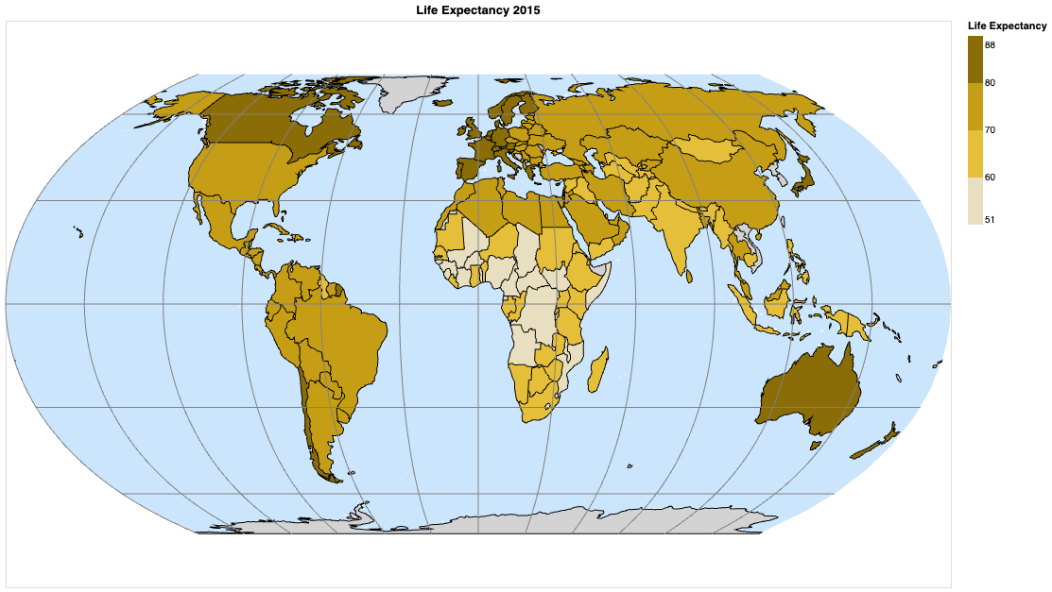

1. The domain of your visualization

• Life Expectancy in 2015

1. The visualised dataset (attribute types, source and author, etc.)

• Author: Kumarra Jarshi from WHO

• URL: <https://www.kaggle.com/datasets/kumarajarshi/life-expectancy-who>

• Attribute types:

Country – Categorical

Year – Categorical

Status – Categorical

Life Expectancy – Quantitative and Ordered

1. Data transformation that you applied (if any), such as normalisation by area or population.

• Remove data not in the year 2015

• Exclude other attributes, only keep (country, year, status, life expectancy) at this stage

• Modify the country names to match in the topojson file

1. A justification for the type of map idiom used. For example, explain why you chose to create a proportional symbol map instead of a choropleth map or a dot map.

• I chose a choropleth map because I only need to show the data in the country, rather than showing a specific position like a dot map (showing information about earthquakes). Or a proportional symbol map would like to compare different categories of data in the same region, my dataset doesn’t have this kind of feature.